Troop 42/422 New Scout checklist

**Youth Paperwork and fees**

__ Youth BSA application filled out, signed, and turned in to Troop 42/422

__ BSA National Yearly dues $80.00 (2024) (paid in previous unit?) Brand new to scouting add $25.00

__ BSA Counsel Yearly Dues $12.00 (2024) (paid in previous unit?)

__ Scout Life subscription $15.00 (paid in previous unit?) Highly suggested, not required

__ $18.00 Yearly Troop 42 dues

__ $50.00 once per family Troop 42 Inc share

__ Troop 42 permission form filled out, signed and on file

# Troop 42/422 Uniform requirements

Note: the Troop will provide a neckerchief, “42” numbers and appropriate “patrol” patch

__ Tan Boy Scout shirt (leave some room to grow)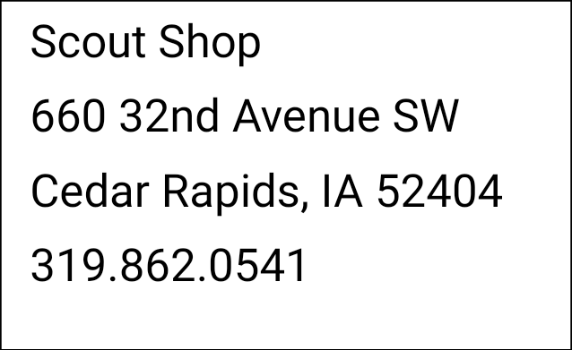

__ Green shoulder loops

__ Council shoulder patch

__ Council circle patch

__ World Scouting patch

__ A slide for your Boy Scout neckerchief

__ Merit Badge sash (buy the large one, we will show you how to shorten it)

__ Boy Scout Handbook (either style okay, we strongly suggest you buy a cover)

Tips and hints:

#1 Be involved the scouts that have active adults get the most out of the program. Please ask lots of questions. Everyone in the troop was new once, we are all scouters and scouters like to help (do a Good Turn Daily).

Visit the Troop Calendar @ <http://www.troop42.com/diary.asp>

Use the troop website @ Troop42.com

Important contact information for new parents:

Membership Chair: Jason Cogdill [Membership@troop42.com](mailto:Membership@troop42.com)

Scoutmaster: Kevin Kropf [Scoutmaster@troop42.com](mailto:Scoutmaster@troop42.com)

Committee chair: Peter Cole [Committeechair@troop42.com](mailto:Committeechair@troop42.com)

Treasures: Clare Fagan [Treasurer@troop42.com](mailto:Treasurer@troop42.com)

Advancement chair: Bill Hudson [Advancment@troop42.com](mailto:Advancment@troop42.com)

Note:

Every scout has a troop account even if it has a balance of zero. Troop 42/422 takes checks only for payments our auditor requires a paper trail. All checks should be written to Troop 42.